GDP Analysis System
Phase 2 — Modular Architecture & Dependency Inversion
Complete Deliverables Report • Deliverables 9 – 14
Deliverable | Description
9 — Package Structure | Modular layout with __init__.py files
10 — config.json | Swappable I/O without Core changes
11 — Architecture Diagram | Class/module diagram with DIP flow
12 — PlantUML | Source code + graphical representation
13 — Structural Skeleton | Python code generated from PlantUML
14 — Implementation | Full working system with all 8 outputs

Deliverable 9 — Modular Package Structure
The project is organised into four distinct logical packages that enforce separation of concerns and enable Dependency Inversion. Each directory contains an __init__.py to be recognised as a proper Python package.

project_root/
├── main.py # Orchestrator / Bootstrap
├── streamlit_app.py # Interactive web dashboard
├── config.json # Runtime I/O configuration
│
├── core/ # Domain layer — owns all Protocols
│ ├── __init__.py
│ ├── contracts.py # DataSink, PipelineService (Protocols)
│ ├── engine.py # TransformationEngine (8 outputs)
│ ├── cleaner.py # Data validation & error reporting
│ ├── transform.py # Wide → Long format conversion
│ ├── process.py # Aggregation (sum / average)
│ ├── filter_by_region.py # Continent filter
│ ├── filter_by_country.py # Country filter
│ ├── load_data.py # CSV loader
│ └── load_json.py # JSON / config loader
│
├── plugins/ # I/O plugins (depend on Core protocols)
│ ├── __init__.py
│ ├── inputs.py # CSVReader, JSONReader
│ ├── outputs.py # ConsoleWriter, GraphicsChartWriter
│ └── dashboard.py # Streamlit results viewer
│
└── data/
└── gdp_with_continent_filled.csv

Rule 1 — Inbound Abstraction
CSVReader and JSONReader never import TransformationEngine.
They interact only with PipelineService defined in core/contracts.py.

Rule 2 — Outbound Abstraction
TransformationEngine never imports ConsoleWriter or GraphicsChartWriter.
It calls self.sink.write(results) — the sink is injected at runtime.

Rule 3 — Core owns all Contracts
Both DataSink and PipelineService protocols live in core/contracts.py.
All dependency arrows in the diagram point TOWARD core/.

Deliverable 10 — config.json
The configuration file is the only place where concrete I/O implementations are named. Swapping input or output requires editing only config.json — zero Core code changes.

{
"input_type": "csv",
"output_type": "graphics",
"data_path": "data/gdp_with_continent_filled.csv",
"analysis": {
"region": ["Europe", "Asia"],
"country": ["Germany", "France", "China", "Japan"],
"year": 2020,
"start_year": 2015,
"end_year": 2020,
"decline_years": 5,
"operation": "average"
}
}

Factory Registry (main.py)
INPUT_DRIVERS = {"csv": CSVReader, "json": JSONReader}
OUTPUT_DRIVERS = {"console": ConsoleWriter, "graphics": GraphicsChartWriter}

def bootstrap():
config = load_json("config.json")
sink = OUTPUT_DRIVERS[config['output_type']]()
engine = TransformationEngine(sink, config['analysis'])
reader = INPUT_DRIVERS[config['input_type']](engine, config['data_path'])
reader.run()

Deliverable 11 — Architecture Diagram
The diagram below shows the complete class and module structure. All dependency arrows point toward the Core, illustrating strict adherence to the Dependency Inversion Principle.

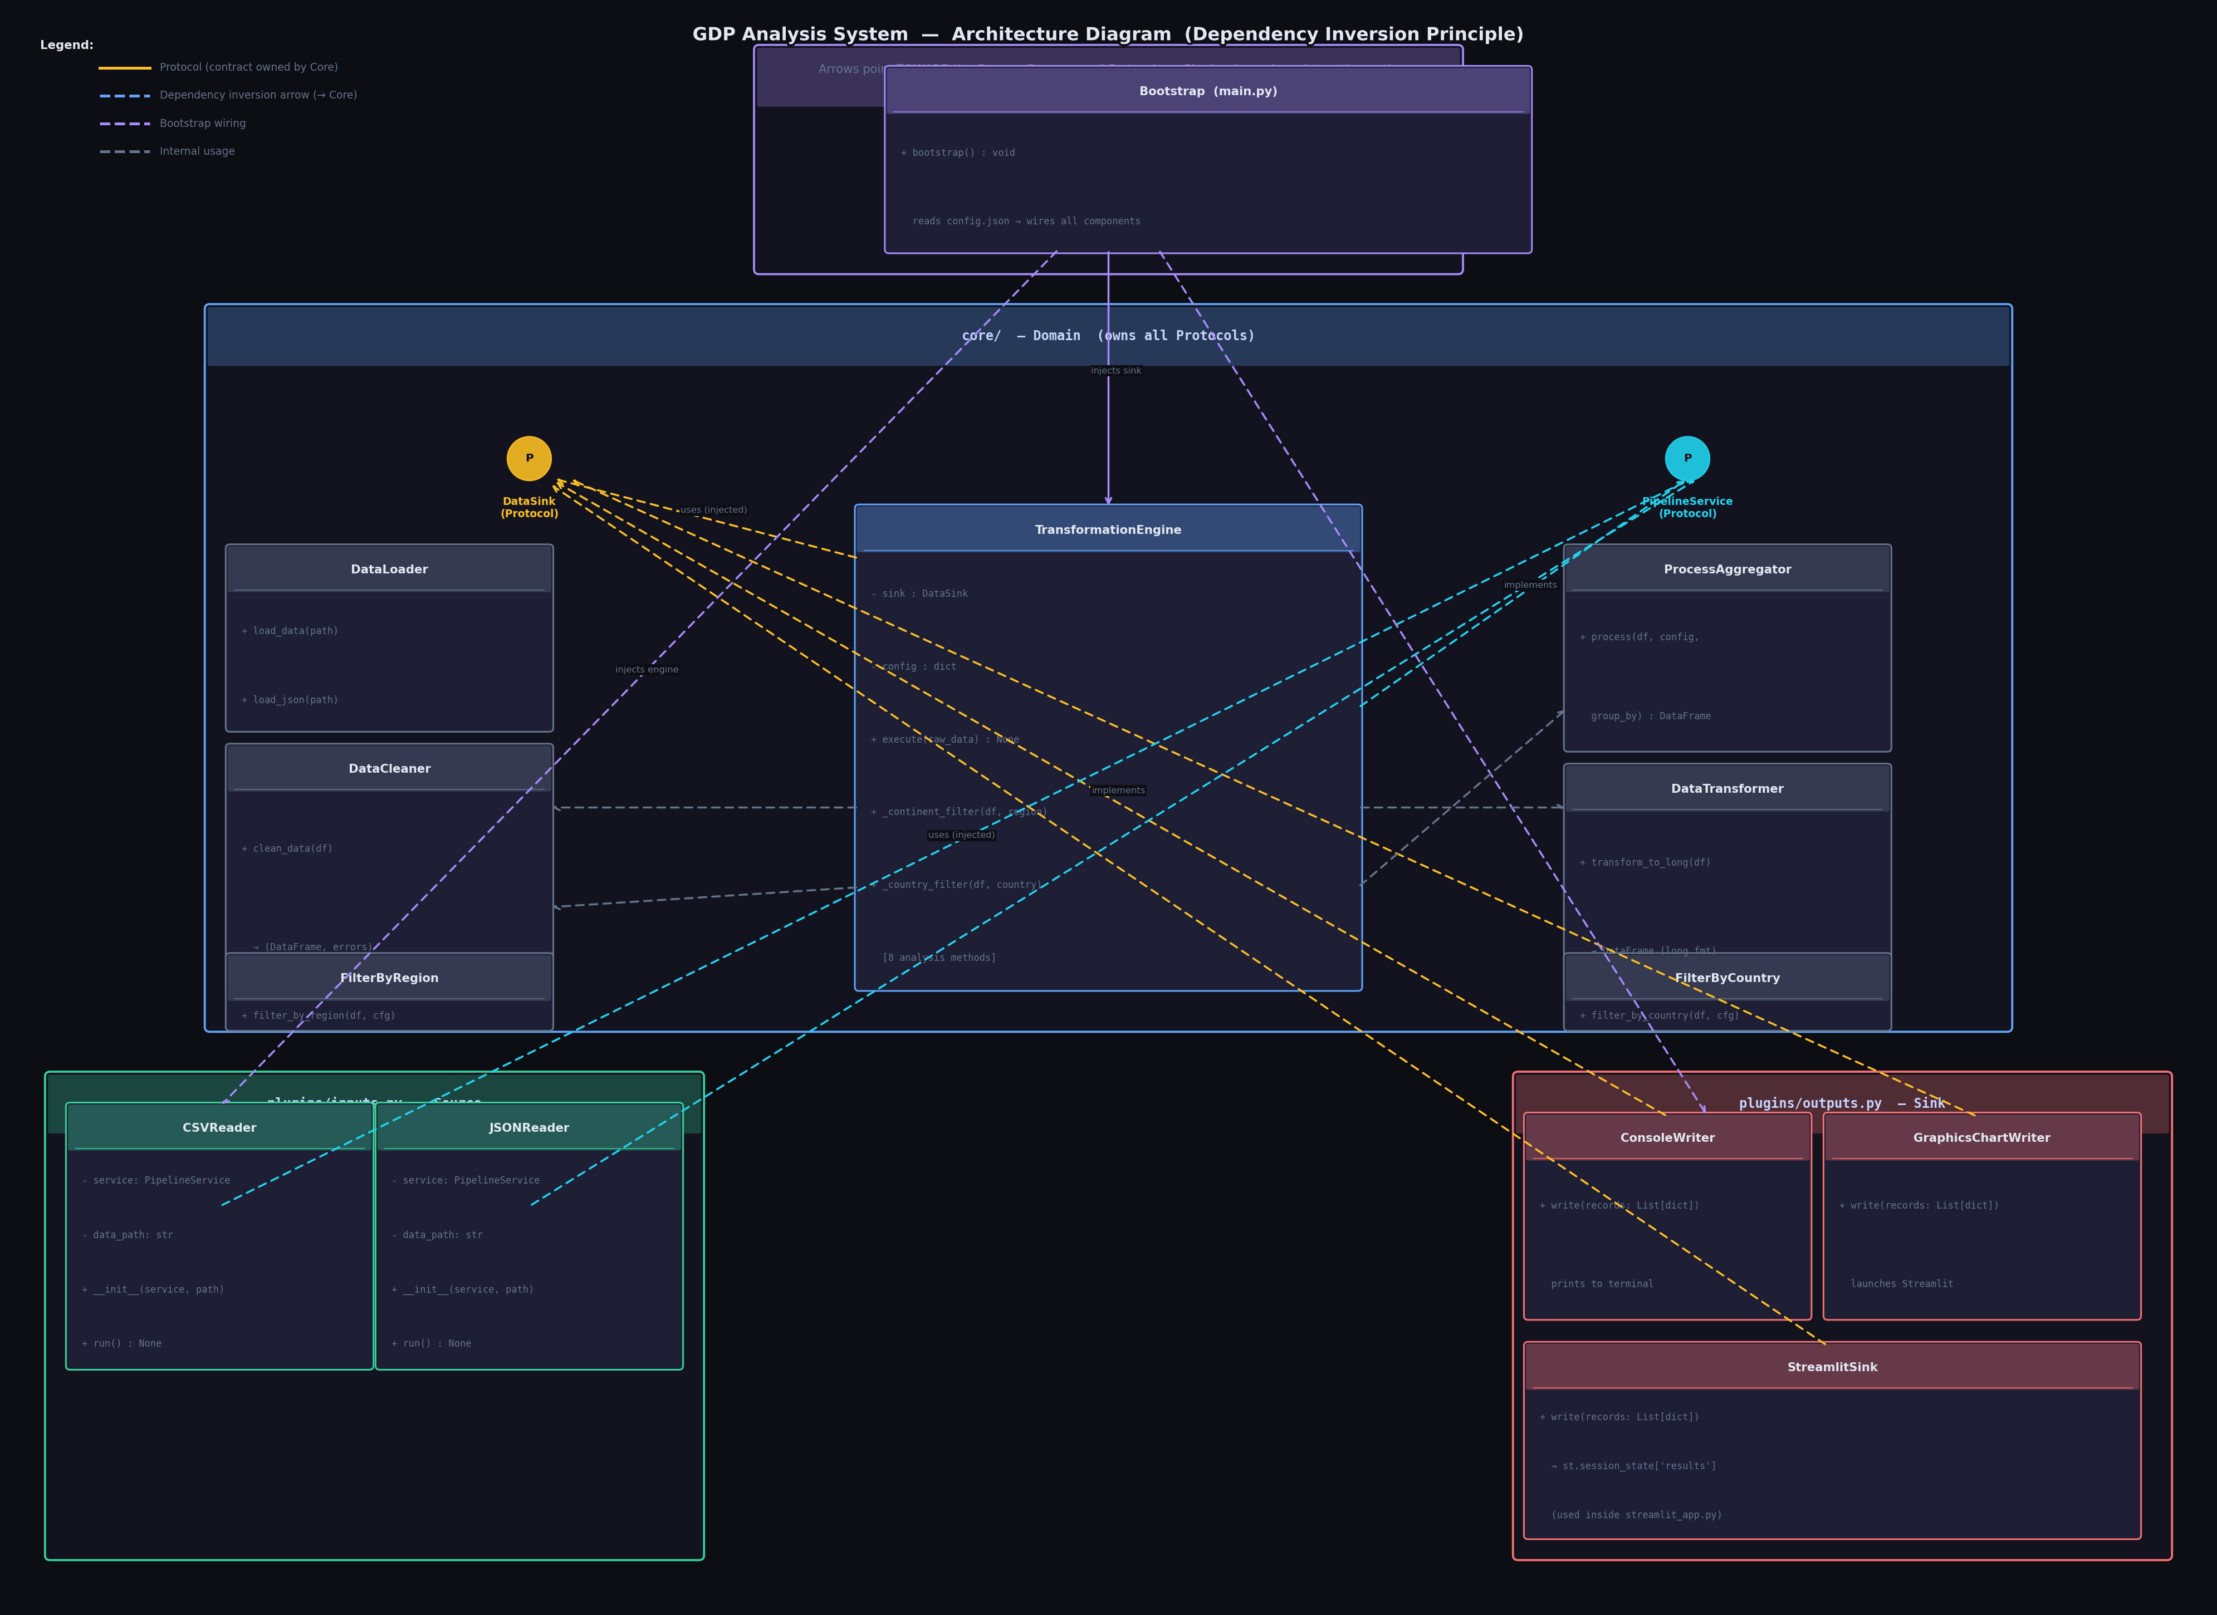

Element | Meaning
Yellow lollipop P | Protocol defined in core/contracts.py
Solid arrow ──► | Implements / satisfies the protocol (structural duck-typing)
Dashed arrow - - ► | Uses (calls methods on an abstraction, never a concrete class)
Purple arrows | Bootstrap wiring — dependency injection at startup
Blue / Amber / Cyan | Colour-coded by which protocol is being satisfied

Deliverable 12 — PlantUML Code & Graphical Representation
The PlantUML source below produces the architecture diagram when rendered. The diagram above (Deliverable 11) is the graphical representation of this PlantUML code.

How to Render
- Online: plantuml.com — paste the code and click Submit
- VS Code: Install PlantUML extension → open .puml file → press Alt+D
- CLI: java -jar plantuml.jar architecture.puml

PlantUML Source (architecture.puml)
@startuml GDP_Analysis_Architecture

!define CORE_COLOR #1a3a5c
!define INPUT_COLOR #1a4a2e
!define OUTPUT_COLOR #4a1a1a
!define MAIN_COLOR #3a2a5c
!define PROTOCOL_COLOR #4a3a0a

skinparam backgroundColor #0d0d14
skinparam defaultFontColor #e2e8f0
skinparam defaultFontName "Arial"
skinparam defaultFontSize 12

skinparam package {
BackgroundColor #13131f
BorderColor #2a2a45
FontColor #c7d2fe
FontSize 13
FontStyle bold
}

skinparam interface {
BackgroundColor #fbbf24
BorderColor #d97706
FontColor #0d0d14
}

skinparam class {
BackgroundColor #1e1e35
BorderColor #3b4a6b
FontColor #e2e8f0
HeaderBackgroundColor #1a2a4a
AttributeFontColor #94a3b8
StereotypeFontColor #60a5fa
}

skinparam arrow {
Color #60a5fa
FontColor #94a3b8
FontSize 10
}

' ─────────────────────────────────────────────────────
' MAIN / ORCHESTRATOR
' ─────────────────────────────────────────────────────
package "main.py (Orchestrator)" <<Rectangle>> {
class Bootstrap {
+ bootstrap() : void
- load_config(path: str) : dict
- wire_components() : void
}
note right of Bootstrap
1. Reads config.json
2. Instantiates Sink
3. Injects Sink → Engine
4. Injects Engine → Reader
5. Calls reader.run()
end note
}

' ─────────────────────────────────────────────────────
' CORE (DOMAIN)
' ─────────────────────────────────────────────────────
package "core/ (Domain — owns all Protocols)" <<Rectangle>> {

interface DataSink <<Protocol>> {
+ write(records: List[dict]) : None
}

interface PipelineService <<Protocol>> {
+ execute(raw_data: List[Any]) : None
}

class TransformationEngine {
- sink : DataSink
- config : dict
+ __init__(sink: DataSink, config: dict)
+ execute(raw_data: List[Any]) : None
- _continent_filter(df, region) : DataFrame
- _country_filter(df, country) : DataFrame
- _top10(df, region, year) : dict
- _bottom10(df, region, year) : dict
- _growth_rate(df, region, start, end) : dict
- _avg_by_continent(df, start, end) : dict
- _global_trend(df, start, end) : dict
- _fastest_continent(df, start, end) : dict
- _decline_countries(df, n_years, end) : dict
- _contribution(df, start, end) : dict
}

class DataCleaner {
+ clean_data(df: DataFrame) : (DataFrame, dict)
}

class DataTransformer {
+ transform_to_long(df: DataFrame) : DataFrame
}

class DataLoader {
+ load_data(path: str) : DataFrame
+ load_json(path: str) : dict
}

class ProcessAggregator {
+ process(df, config, group_by) : DataFrame
}

class FilterByRegion {
+ filter_by_region(df, config) : DataFrame
}

class FilterByCountry {
+ filter_by_country(df, config) : DataFrame
}
}

' ─────────────────────────────────────────────────────
' INPUT PLUGINS
' ─────────────────────────────────────────────────────
package "plugins/inputs.py (Source)" <<Rectangle>> {
class CSVReader {
- service : PipelineService
- data_path : str
+ __init__(service: PipelineService, path: str)
+ run() : None
}

class JSONReader {
- service : PipelineService
- data_path : str
+ __init__(service: PipelineService, path: str)
+ run() : None
}
}

' ─────────────────────────────────────────────────────
' OUTPUT PLUGINS
' ─────────────────────────────────────────────────────
package "plugins/outputs.py (Sink)" <<Rectangle>> {
class ConsoleWriter {
+ write(records: List[dict]) : None
}

class GraphicsChartWriter {
+ write(records: List[dict]) : None
}

class StreamlitSink {
+ write(records: List[dict]) : None
}
}

' ─────────────────────────────────────────────────────
' RELATIONSHIPS
' ─────────────────────────────────────────────────────

' Core owns both protocols (they live in core/contracts.py)
TransformationEngine .up.|> PipelineService : implements
ConsoleWriter .up.|> DataSink : implements
GraphicsChartWriter .up.|> DataSink : implements
StreamlitSink .up.|> DataSink : implements

' Engine depends on DataSink abstraction (injected)
TransformationEngine o--> DataSink : uses (injected)

' Readers depend on PipelineService abstraction (injected)
CSVReader o--> PipelineService : uses (injected)
JSONReader o--> PipelineService : uses (injected)

' Engine uses core helpers
TransformationEngine ..> DataCleaner : uses
TransformationEngine ..> DataTransformer : uses
TransformationEngine ..> ProcessAggregator: uses
TransformationEngine ..> FilterByRegion : uses
TransformationEngine ..> FilterByCountry : uses

' Bootstrap wires everything
Bootstrap ..> DataLoader : loads config/data
Bootstrap ..> ConsoleWriter : instantiates
Bootstrap ..> GraphicsChartWriter : instantiates
Bootstrap ..> TransformationEngine: instantiates & injects sink
Bootstrap ..> CSVReader : instantiates & injects engine
Bootstrap ..> JSONReader : instantiates & injects engine

@enduml

Deliverable 13 — Structural Python Code from PlantUML
Every class, method signature, Protocol, and relationship from the PlantUML diagram is expressed in Python below. This is the structural skeleton — implementation details live in the individual module files.

core/contracts.py
from typing import Protocol, List, Any, runtime_checkable

@runtime_checkable
class DataSink(Protocol):
"""Outbound Abstraction — Core calls this to deliver results."""
def write(self, records: List[dict]) -> None: ...

@runtime_checkable
class PipelineService(Protocol):
"""Inbound Abstraction — Input plugins call this to push data."""
def execute(self, raw_data: List[Any]) -> None: ...

core/engine.py
class TransformationEngine: # implements PipelineService (duck-typing)
def __init__(self, sink: DataSink, config: dict) -> None:
self.sink = sink # injected — no concrete import
self.config = config
def execute(self, raw_data: List[Any]) -> None: ...
def _top10(self, df, region, year) -> dict: ...
def _bottom10(self, df, region, year) -> dict: ...
def _growth_rate(self, df, region, s, e) -> dict: ...
def _avg_by_continent(self, df, s, e) -> dict: ...
def _global_trend(self, df, s, e) -> dict: ...
def _fastest_continent(self, df, s, e) -> dict: ...
def _decline_countries(self, df, n, end) -> dict: ...
def _contribution(self, df, s, e) -> dict: ...

plugins/inputs.py
class CSVReader:
def __init__(self, service: PipelineService, data_path: str): ...
def run(self) -> None: ...

class JSONReader:
def __init__(self, service: PipelineService, data_path: str): ...
def run(self) -> None: ...

plugins/outputs.py
class ConsoleWriter: # satisfies DataSink
def write(self, records: List[dict]) -> None: ...

class GraphicsChartWriter: # satisfies DataSink
def write(self, records: List[dict]) -> None: ...

class StreamlitSink: # satisfies DataSink
def write(self, records: List[dict]) -> None: ...

main.py
INPUT_DRIVERS = {"csv": CSVReader, "json": JSONReader}
OUTPUT_DRIVERS = {"console": ConsoleWriter, "graphics": GraphicsChartWriter}

class Bootstrap:
def bootstrap(self) -> None:
config = self._load_config("config.json")
sink = OUTPUT_DRIVERS[config['output_type']]()
engine = TransformationEngine(sink, config['analysis'])
reader = INPUT_DRIVERS[config['input_type']](engine, config['data_path'])
reader.run()

Deliverable 14 — Full Implementation Details

8 Required Analysis Outputs
# | Analysis Output
1 | Top 10 Countries by GDP for selected continent(s) & year
2 | Bottom 10 Countries by GDP for selected continent(s) & year
3 | GDP Growth Rate of each country in continent for date range
4 | Average GDP by Continent for given date range
5 | Total Global GDP Trend for given date range
6 | Fastest Growing Continent for given date range
7 | Countries with consistent GDP decline in last N years
8 | Contribution of each continent to Global GDP for date range

Data Flow (End-to-End)
- config.json is read by Bootstrap.
- Bootstrap instantiates the concrete Sink (ConsoleWriter or GraphicsChartWriter).
- Bootstrap instantiates TransformationEngine, injecting the Sink.
- Bootstrap instantiates Input reader (CSVReader or JSONReader), injecting the Engine.
- reader.run() loads raw data, cleans via DataCleaner, transforms via DataTransformer, calls engine.execute(records).
- TransformationEngine computes all 8 results and calls sink.write(results).
- Sink prints to console, launches Streamlit, or stores in session_state.

Multi-Region & Multi-Country Support
- config.json accepts arrays for both region and country fields.
- Streamlit UI provides a multiselect for continents and a comma-separated text field for countries.
- Engine's _continent_filter() uses .isin() for lists and == for single strings.
- Top 10 / Bottom 10 / Growth Rate: separate subplot panels per region + a grouped comparison bar.
- Global outputs (Trend, Avg, Contribution): always combined — no split needed.

Interactive Streamlit Dashboard
- All 8 outputs rendered as interactive Plotly charts (hover, zoom, pan, legend toggle).
- Data Quality Report page with colour-coded error cards and bar chart of error counts.
- 50% validity gate blocks processing if fewer than half the rows pass validation.
- Re-Filter sidebar: change region / year / operation without re-uploading data.
- Export button downloads the filtered dataset as CSV.

Key Technical Decisions
Decision | Rationale
typing.Protocol for DIP | Structural typing — no inheritance; duck-typing keeps plugins decoupled
Dictionary-based Factory | New I/O plugin = one line in registry; zero Core changes
Year cast to int | Prevents silent comparison failures between pandas Int64 and Python int
Engine receives unfiltered data | Engine needs full year range for outputs 3–8; year filter only for stats display
Plotly over Matplotlib | Interactive hover, zoom, legend toggle in browser — no static screenshots
Subplot grid for multi-region | Separate panels for rankings; shared axes for global outputs
DataSink as Streamlit bridge | StreamlitSink satisfies DataSink without any Core changes

